Swindon Borough Council Website – How to submit planning comments
The portal is not user friendly, so please follow the steps carefully.
Firstly, You Need To Register, as follows:
- Click the link below:
=Registration
- Complete your personal details, create a password and select “next”
- Fill in your postcode and select “next”
- Select your address from the dropdown menu and select “next”
- Check your details are correct, click to agree the “terms and conditions” and select “next”
- You will now need to go to your email to activate your account
- Click the link in the email and then click “confirm”
- You are now registered.
You can now login with the email and password you registered with and submit your comments.
- Select “login”
- Enter the email address and password you registered with
- Once logged in, select the down arrow next to “search”
- Select “planning” and “simple search”
- In the search section type “1177” – you should see this at the top
  - 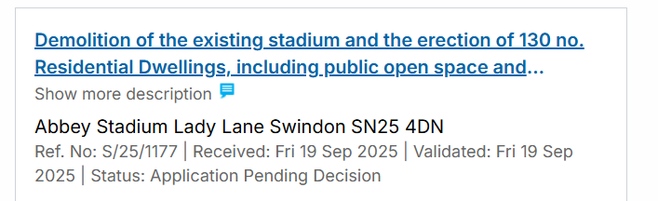
- Click on the link and you will be taken to the page for application S/25/1177
- Select “Comments”
- Change “Commentator Type to “objector”
- Select “object” from the “stance” section
- Now copy your objection planning reasons into the “your comment” box (max 3000 characters) and press submit

Now repeat from step 5 onwards, but search for “1182” and not “1177”
